Wednesday, February 18, 2026

To the Board of Directors of BIA Name Here:

Dear BIA Name Board,

It is our understanding that Person’s Name Here from your BIA has expressed an interest in joining the Board of Directors of the Ontario BIA Association. We are delighted that they wish to stand for election at our AGM in March, and we want to let you know what is involved should they be selected by the membership.

OBIAA is a valuable tool for all Business Improvement Areas. Networking and sharing of ideas such as event coordination, marketing, beautification, and parking are just some examples of the issues and challenges that we all share. We get support and energy from one another and in turn we contribute to the health of all main street and commercial core areas.

The OBIAA board currently meets monthly, via virtual platforms. However, there are two in-person meetings at different BIA locations throughout the province anticipated annually. All meetings have virtual participation (hybrid) options, if necessary. Additionally, OBIAA organizes an annual BIA Conference in Ontario. Board members are expected to obtain financial support from their BIA before standing for election, a budget of $2,000 per year for this purpose is suggested (Estimated costs involved would be mileage/travel, meals, and, depending on location, accommodations). OBIAA has a small bursary pool for Board Members for whom in-person attendance would cause financial hardship to the BIA. In those cases, up to $400 is available (per meeting) if travel is more than 250KM (one way) and $600 if travel is more than 500KM (one way). The only exception to this is Board Meetings held during the annual OBIAA Conference.

To continue building our association, attendance at Board meetings and the Conference is a very important task for the OBIAA board. To assist us in keeping costs low, we ask that each BIA board be supportive and send their representative to participate in these ongoing functions of OBIAA.

Time given for Board and Committee work should be defined as well.

In addition, each board member may participate by hosting one of our twice annual meetings. This involves organizing the meeting space, meal requirements, travel information and hotel accommodations. The OBIAA board is very appreciative of any financial assistance offered by their own board of management or municipality.

With all of this in mind, candidates are required to provide a letter from the BIA Chair, confirming support for the candidate. Please provide that to them before Monday, March 16, 2026.

Thank you for your continued commitment to support OBIAA. If you have any questions or concerns, please do not hesitate to contact our Executive Director directly at 647-521-5341.

Sincerely,

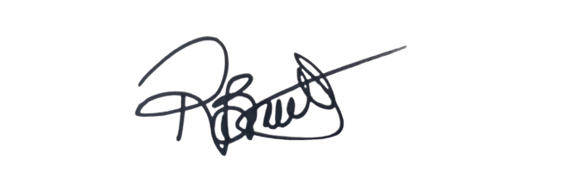
Rachel Braithwaite, OBIAA Executive Director

