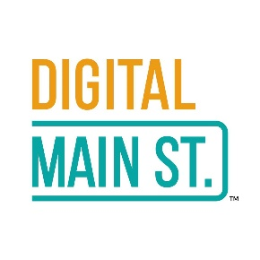
This project is funded in part by the Government of Canada through the Federal Economic Development Agency for Southern Ontario

Email Copy to send to Members
Email Subject:

$2,500 Digital Transformation Grants NOW Available

Suggested email copy to Members:

Dear {first name}:

Our BIA is thrilled to let you know that applications are now being accepted for the new round $2,500 Digital Main Street Transformation Grants! The deadline to apply is November 30, 2020, so apply early!

Digital Main Street is an exciting initiative that has expanded across Ontario thanks to a partnership between the Government of Canada, the Province of Ontario, TABIA, and the Ontario BIA Association to help small main street businesses improve how they use digital technologies to promote and run their businesses.

It is free to apply and the process is simple:

- Register your business at digitalmainstreet.ca/Ontariogrants and complete the digital assessment.
- Pass the eligibility evaluation, complete the 2.5 hours of online training, and develop your Digital Transformation Plan.
- Apply for a $2,500 grant.

In addition to grants, businesses can also access digital vendors, online and in-person training, free trials and discounts, interesting articles, how-to tips, and much more.

Learn more and see if your business qualifies at digitalmainstreet.ca/Ontariogrants [and refer to the Backgrounder and FAQs attached].

Best regards,

